JOB NARRATIVE
- Job Purpose and Roles and Responsibilities of the Job
- Organisation Structure, Outcomes/Value Add, Financials & Work Relations

Basic Details
Job Title | Shift In charge – AN/ NAP
Job Grade/ Level
Function | Manufacturing 2 –  Production / Operations AN ANP
Business Sector | K1 – Industrial Chemicals & CNB
Location | Taloja
Occupied/ Vacant | -
Name of the Job Holder (Current, if occupied) | -
Date (Last updated) | -
Approved by

Organisation Structure
(where does the position stands in the organisation structure of the Business)
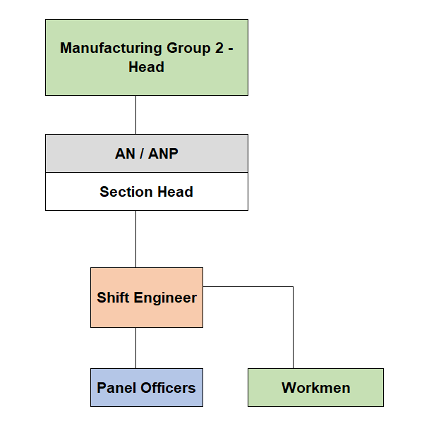
Position of the incumbent

Job Purpose:
- Summarizes the main points of the job description which may include key responsibilities, functions, and duties
- Job Purpose is the prime objective for which the Job holder is responsible for. It is directly controlled by the Job holder
- Should contain 1 - 3 key points
- To operate the plant safely to produce AN Melt , LDAN & ANP conforming to set specifications with highest possible productivity level and meet the overall set Budget norms complying with EHS & Legal aspects.
- To carryout Phosphuric , Sulphuric Caustic Acids tanker unloading operations and AN melt tanker loading operations safely meeting set targets.
To take quick decisions during emergencies & plant upsets to minimize consequential damage to properties.
- To plan, control In-process quality control systems.

Key Accountabilities & Outcomes
Key Accountability  - Main areas of accountability / key goals of the Job.  - Should contain five to Seven Key Accountabilities.  - Can be derived through Balanced Score Card Perspectives (Financial, Customer, Internal Process & Learning and Growth) | Major Activities/ Tasks  - The tasks under Key Responsibility that the Job holder is suppose to perform to achieve the business goals
- Plant operations | - Deployment of adequate manpower to ensure smooth & safe operation.  - Optimizing the plant parameters to meet the plant efficiencies.  - To plan the maintenance of equipments which will include the safe handing over & taking back without adversely affecting the production target.  - Co-ordination with all other plant shift in charges for utilities, power & other inputs for smooth operation.  - To meet Product dispatch requirements.  - Trouble shooting effectively to reduce potential hazards & downtime.  - Bring in improvement schemes based on the experiences during shift operations.  - Close monitoring of shutdown & start up activities.  - Monitoring of Loss points of Materials handled.  - Ensuring the availability of  - Standby equipments.  - Lab Analysis of samples other than R. Material/ final product.
- EHS & statutory compliance | - Monitoring of safety interlocks & ensuring they are healthy.  - To assess the hazards associated with jobs (IER & HIRA) and take appropriate actions to eliminate or minimize the effects.  - To ensure the personnel working under him wears proper PPE.  - To identify any existing unsafe condition & take corrective actions immediately.  - Acting as an Incident Controller as per ''On-site Emergency plan''  - Ensure all jobs are carried out as per given SOP/ Checklist/OCP.  - Ensuring the plant, equipments, work place clean & safe.  - Monitor effluent quality and ensuring no ingress of process effluent to SWD.  - Reporting of Near Miss Accidents.  - Completing the tasks assigned to achieve and improve IMS Maturity/ any EHS related initiatives.  - SAP related activities  - Compliance to all statutory standards using live IMS documents  - Daily upkeep 5s of plant during shift operations.
- Team Working  Training & Development | - On the job training of subordinates.  - De-briefing of Job Instructions.  - Holding informal discussions on plant related technical /EHS issues and updation of documents.  - Periodic refresher training on SOP.  - Motivating subordinates by role model.
- Process improvement drives. | - Carrying out the activities as instructed for any Improvement Drives adopted.
- Establishment & sustenance of TPM practices | - To carry out TPM initiatives at plant level by involving other team members

Work Relations ( Internal and External)
Internal Relations  - Main interface of the Job Holder(Working relationships with Key stakeholders/ internal customers  - Other Job Holders that the Job holder have may to liaise, report or coordinate with | External Relations  - Main interface of the Job Holder(Working relationships with Key stakeholders/ external customers
- Group- head and in his absence to Unit Head.  - Marketing Team ,AN ANP Plant head, Panel manager, field operators, site Shift Manager. Laboratory, maintenance departments, other division plants, EHS, HR ,Admin, Security & other related support functions on daily basis | - Customers , Vendors  - Contract Labour

Key Dimensions
Financial Dimensions  - List the significant numerical data which will reflect the scope and scale of activities concerning this job such as budget, cost, revenue etc. | People Dimensions  - Mention the team size ( direct reportees only) the Job Holder would have to manage for the scope of activities concerning to this role

ACHIEVEMENT PROFILE
- What are the capabilities required by the Job Holder at this position
- Specify Knowledge ( technical expertise), experience, skills, behavioural competencies, personality required
- It depicts candidate profile for making hiring decision and helps incumbent profile for competency mapping

Education Qualifications / Background
- State minimum qualification required by the Job Holder to work effectively on this position
- BE/ B Tech Chemical Engineering
Relevant and Total Years of Experience
- Mention years of experience required for the job
- Elaborate more of the relevance / type of the job experience required by the role
- Minimum 5-10 years’ experience in relevant field. (experience in Continuous process plant )
Technical/Functional Expertise
- Stare minimum proficiency required on specific technical or functional skills required for the Job Role
- Technical knowledge of Petrochemical/Chemicals/ Fertilisers plant operation.
- Analytical skills
- Trouble shooting and problem solving skills
- High level of inter personal skills
- Understanding of business environment
- EHS Norms & it's impact on Business.
Behavioural Competencies (List only 3- 5 specific behavioural competencies)
- State behavioural competencies required to function effectively at this position
- Knowledge of chemical engineering
- Thorough knowledge of operation of continuous chemical process plant
- Knowledge of safety and pollution control norms
- Good interpersonal skills Manpower handling skills
- Good communication skills.
- Team leadership.
- Computer literacy.
- Highly Vigilant and high level of alertness.
- Trouble shooting skills
Personality (List only 3- 5 specific personality characteristics)
- Write personal characteristics/ personality type that is suitable to work at this job level.

- Respect
- Integrity
- Excellence in whatever we do
- Well -being of others

